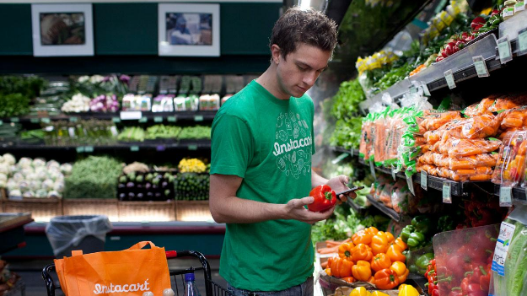
Instacart Market Basket Analysis



Acknowledgment

It is our privilege to express our sincerest regards to our professor, Indranil Bose for his valuable inputs, able guidance, encouragement, whole-hearted cooperation and constructive criticism throughout the duration of our project. This has been a wonderful project which has helped us to explore the world of text analytics and its real world application. We also take this opportunity to thank all our professors who have directly or indirectly helped our project. Last but not the least we express our thanks to our classmates for their cooperation and support.

Table of Contents
- Instacart Company Profile
- History of Instacart
- Problem Statement
- Data Exploration
- Data Engineering
- Data Modelling
- Model Validation (Mean F1 Score)

INSTACART
Instacart is an American company that operates as a same-day grocery delivery service. Customers select groceries through a web application from various retailers and delivered by a personal shopper. Up until the end of 2017, Instacart only has operations and services in the United States.

How they Service : Instacart's service is mainly provided through a smartphone app, available on iOS and Android platforms, apart from its website. Customers can pay with Android Pay and Apple Pay on their respective platforms. Initially Instacart shoppers simply went to a store and purchased the ordered items at retail and, in addition to the delivery charge, added a markup of 10 to 20 percent.As the business has developed, the firm has established relationships with grocery firms which share their (store) existing markup, allowing Instacart users to shop at in-store prices

Instacart’s data science team plays a big part in providing this delightful shopping experience. Currently they use transactional data to develop models that predict which products a user will buy again, try for the first time, or add to their cart next during a session. Recently, Instacart open sourced this data - see their blog post on 3 Million Instacart Orders, Open Sourced. “The Instacart Online Grocery Shopping Dataset 2017”. This anonymized dataset contains a sample of over 3 million grocery orders from more than 200,000 Instacart users.

INTRODUCTION
The Instacart Online Grocery Shopping Dataset 2017:

orders.csv: This file gives a list of all orders we have in the dataset. 1 row per order. For example, we can see that user 1 has 11 orders, 1 of which is in the train set, and 10 of which are prior orders. The orders.csv doesn’t tell us about which products were ordered. This is contained in the order_products.csv
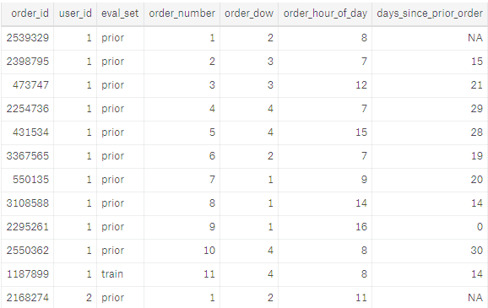
order_products__train : This file gives us information about which products (product_id) were ordered. It also contains information of the order (add_to_cart_order) in which the products were put into the cart and information of whether this product is a re-order(1) or not(0).
For example, we see below that order_id 1 had 8 products, 4 of which are reorders.
Still we don’t know what these products are. This information is in the products.csv
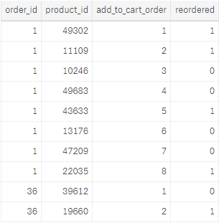

products.csv : This file contains the names of the products with their corresponding
product_id. Furthermore the aisle and deparment are included.
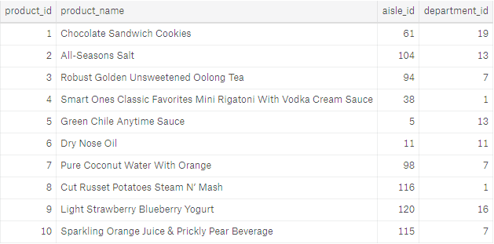
order_products_prior : This file is structurally the same as the other_products_train.csv.
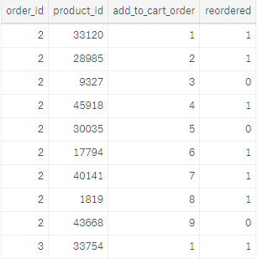
aisles.csv : This file contains the different aisles.
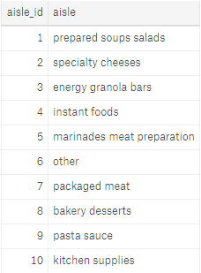
Departments.csv:
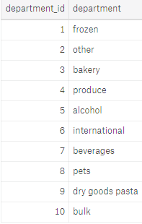

Overall Datasets Mapping
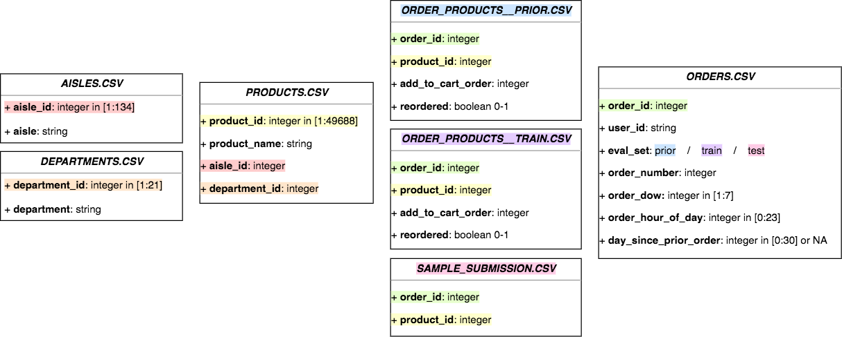

Initial Descriptive analysis :

When people buy Groceries online

